Antacid **Written Signature Assignment**

Your name: Cieran Wong Your email: cieranwong@arizona.edu

Your lab partner’s name(s): Nick Samuels Your lab partner’s email(s): nssamuels014@arizona.edu

Your lab instructor’s name:Pedro Your lab section:2A

*All work must be* ***very neat*** *and* ***organized****.* *If you need to collect your thoughts, please use a separate sheet of paper. Written Signature Assignments are an* ***individual******effort****. Please submit the completed document to the* ***Antacid Written Signature Assignment*** *D2L DropBox folder before the scheduled end of lab.*

1. **Proposal 1 Implementation: Your Group’s *VCO2* vs. *mbase* Data**. In **Table APSA 1** below, present your group’s **experimental data** from Session 2 (**Proposal 1** implementation). That is, for your group only, give each member’s contribution towards generating data to build a *VCO2* vs. *mbase* plot for *one* of the **knowns** (either CaCO3 or NaHCO3).

**Table APSA 1**: Group’s Data Contribution to the Class Data Set from Session 2 (**Proposal 1** implementation)

|  |  |  |  |  |  |
| --- | --- | --- | --- | --- | --- |
| **Volume** of **0.3 M HCl** | **Mass** of **Base**  (Specify CaCO3 or NaHCO3) | **Initial Volume** Reading from Gas Collection Graduated Cylinder | | **Final Volume** Reading from Gas Collection Graduated Cylinder | **Volume** of **CO2** Collected |
| NaHCO3 used | | | CO2 produced | | | |
| Mass (grams) | | | Volume (mL) | | | |
| 0.025 | | | 15 | | | |
| 0.05 | | | 21 | | | |
| 0.075 | | | 22 | | | |
| 0.1 | | | 37 | | | |
| 0.125 | | | 41 | | | |
| 0.175 | | | 53 | | | |
| 0.25 | | | 67 | | | |
| 0.3 | | | 68 | | | |
| 0.35 | | | 68 | | | |
| 0.4 | | | 68 | | | |
| 0.45 | | | 68 | | | |
| 0.5 | | | 68 | | | |

|  |  |
| --- | --- |
| CaCO3 used | CO2 produced |
| Mass (grams) | Volume (mL) |
| 0.025 | 8 |
| 0.075 | 25 |
| 0.125 | 36 |
| 0.175 | 36 |
| 0.225 | 36 |
| 0.275 | 36 |
| 0.325 | 36 |
| 0.375 | 36 |
| 0.425 | 36 |
| 0.475 | 36 |
| 0.5 | 36 |

2. ***VCO2* vs. *mbase* Graphs**. Paste-in or very accurately draw the *VCO2* vs. *mbase* plots for the two (2) **knowns** (CaCO3 and NaHCO3) based on the *class data* (which should include your contributions recorded in **Table APSA 1**). Reminder: whenever graphs or plots are presented, you are expected to properly scale, title, and label them using the correct units and appropriate sig figs.

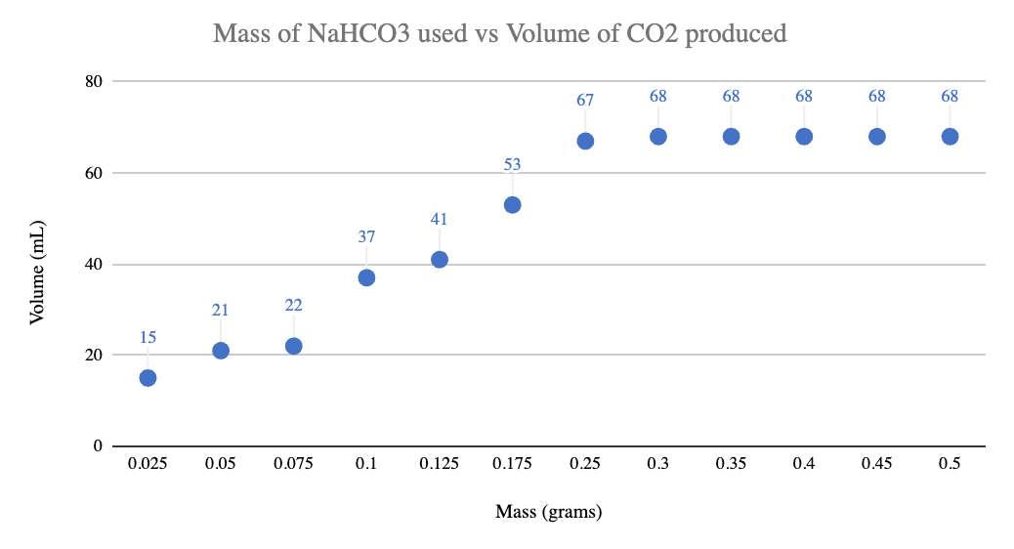

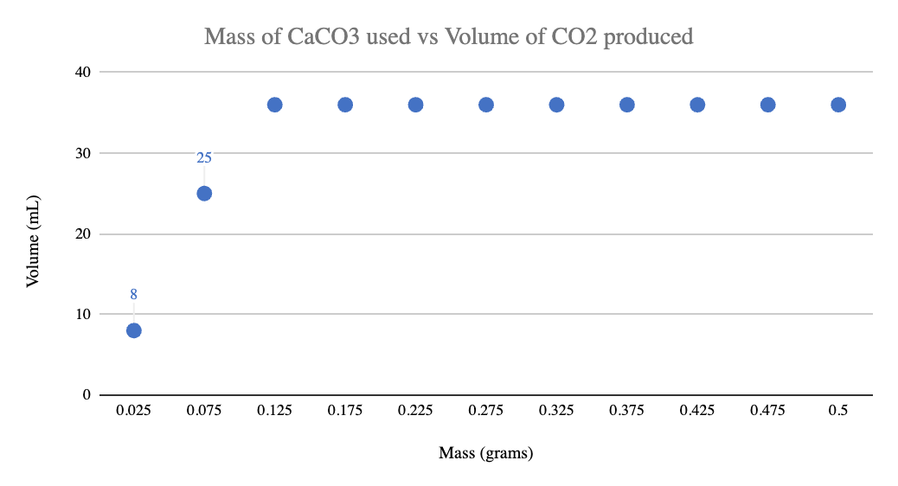

1. **Proposal 2 Implementation: Your Group’s *VCO2* vs. *mantacid*** **Data**. In **Table APSA 2** below, present your group’s **experimental data** from Session 3 (**Proposal 2** implementation). That is, for your group only, give each member’s contribution towards generating data to build a *VCO2* vs. *mantacid* plot for *one* of the **unknown antacids** (either Equate or Rugby).

For my own trials:

Mass of equate tablet: 1.309 grams

Trial 1: 0.075 g of equate. Starting 4mL Final 19mL: 15mL

Trial 2: 0.1 grams. Starting 5mL Final 21mL: 16mL

**Table APSA 2**: Group’s Data Contribution to the Class Data Set from Session 3 (**Proposal 2** implementation)

|  |  |  |  |  |
| --- | --- | --- | --- | --- |
| **Volume** of **0.3 M HCl** | **Mass** of **Antacid (Rugby)** | **Initial Volume** Reading from Gas Collection Graduated Cylinder **(mL)** | **Final Volume** Reading from Gas Collection Graduated Cylinder **(mL)** | **Volume** of **CO2** Collected |
| 10 | 0.025 | 8 | 20 | 12 |
| 10 | 0.075 | 2 | 25 | 23 |
| 10 | 0.125 | 2 | 37 | 35 |
| 10 | 0.175 | 6 | 52 | 46 |
| 10 | 0.225 | 1 | 60 | 59 |
| 10 | 0.275 | 0 | 61 | 61 |
| 10 | 0.325 | 5 | 71 | 66 |
| 10 | 0.375 | 2 | 71 | 68 |
| 10 | 0.425 | 11 | 77 | 68 |
| 10 | 0.475 | 5 | 73 | 68 |
| 10 | 0.5 | 10 | 78 | 68 |

|  |  |  |  |  |
| --- | --- | --- | --- | --- |
| **Volume** of **0.3 M HCl (mL)** | **Mass** of **Antacid (Equate) (grams)** | **Initial Volume** Reading from Gas Collection Graduated Cylinder **(mL)** | **Final Volume** Reading from Gas Collection Graduated Cylinder **(mL)** | **Volume** of **CO2** Collected **(mL)** |
| 10 | 0.025 | 12 | 22 | 10 |
| 10 | 0.05 | 13 | 25 | 12 |
| 10 | 0.075 | 4 | 19 | 15 |
| 10 | 0.1 | 5 | 21 | 16 |
| 10 | 0.15 | 4 | 24 | 20 |
| 10 | 0.2 | 9 | 33 | 24 |
| 10 | 0.25 | 6 | 34 | 28 |
| 10 | 0.3 | 8 | 45 | 37 |
| 10 | 0.35 | 7 | 45 | 38 |
| 10 | 0.4 | 11 | 49 | 38 |
| 10 | 0.45 | 6 | 44 | 38 |
| 10 | 0.5 | 10 | 48 | 38 |

4. ***VCO2* vs. *mantacid* Graphs**. Paste-in or very accurately draw the *VCO2* vs. *mantacid* plots for the two (2) **unknown antacids** (Equate and Rugby) based on the *class data* (which should include your contributions recorded in **Table APSA 2**).

5. **Claims**.

1. **Primary active ingredient** in the antacid **Equate** is the base ___________ CaCO3_______ .
2. **Primary active ingredient** in the antacid **Rugby** is the base ______ NaHCO3 ____________ .
3. **Acid neutralizing capacity** of the antacid **Equate** is _________8.571 M/grams_________ .
4. **Acid neutralizing capacity** of the antacid **Rugby** is ________8 M/grams__________ .
5. **Mass percent of** **inert components** in the **Equate** antacid tablet formulation is ______64.29%____________ .
6. **Mass percent of inert components** in the **Rugby** antacid tablet formulation is _______20%___________ .
7. The data indicates the commercial antacid of superior **acid neutralizing capacity** is _____Equate_____________ .

6. **Justification of the Claims**.

6a. In complete, well-written sentences, succinctly explain how and why the data and results recorded above supports claim **a)**. That is, give your reasoning that defends your claim using the above experimental evidence.

The data from the known experiments that were done, implementing Proposal 1 showed that the data of CaCO3 were similar to the data of Equate. CaCO3 had an inflection point at 36 mL and Equate had an inflection point at 38 mL.

6b. In complete, well-written sentences, succinctly explain how and why the data and results recorded above supports claim **b)**. That is, give your reasoning that defends your claim using the above experimental evidence.

Similar to part a), our data from the known experiments showed that NaHCO3 had the data that was closest in comparison to Rugby. The inflection point for NaHCO3 was 68 mL and the inflection point for Rugby was also 68 mL.

6c. Justify claim **c)** by presenting in a highly organized manner the detailed calculation(s) to determine the acid neutralizing capacity of Equate. [Calculation(s) for the *molHCl* neutralized per gram of antacid (*mantacid*)].

6d. Justify claim **d)** by presenting in a highly organized manner the detailed calculation(s) to determine the acid neutralizing capacity of Rugby. [Calculation(s) for the *molHCl* neutralized per gram of antacid (*mantacid*)].

6e. In complete, well-written sentences, succinctly explain how (citing the important numerical values) you determined the mass percent of inert components in the Equate formulation (mass of inert components divided by the Equate mass times 100) to justify claim **e)**.

To calculate the mass % of inert components, I use the following equation with the Known mass of CaCO3 at its inflection point minus the Unknown mass of Equate at its inflection point.

$$Mass \% of inert components = \frac{Known mass at inflection point - Unknown mass at inflection point}{Mass of Unknown at inflection point} = \frac{0.125 grams - 0.35 grams}{0.35 grams} = |-0.6429|x 100 = 64.29\%$$

6f. In complete, well-written sentences, succinctly explain how (citing the important numerical values) you determined the mass percent of inert components in the Rugby formulation (mass of inert components divided by the Rugby mass times 100) to justify claim **f)**.

To calculate the mass % of inert components, I use the following equation with the Known mass of NaHCO3 at its inflection point minus the Unknown mass of Rugby at its inflection point.

$$Mass \% of inert components = \frac{Known mass at inflection point - Unknown mass at inflection point}{Mass of Unknown at inflection point} = \frac{0.3 grams - 0.375 grams}{0.375 grams} = |-0.2|x 100 = 20\%$$

6g. In complete, well-written sentences, succinctly justify claim **g)**.

For the ANC value, the one with the higher ANC is the superior neutralizer as it needs less mass of the bass to reach its inflection point and neutralize. In this case it is Equate as it needs only 0.35 grams compared to Rugby’s 0.375 grams.

7. **Reflection 1**. In complete, well-written sentences indicate the important chemical ideals or concepts you learned through this *Project*.

I learned about neutralizing a base, how to determine how much of a base is needed to neutralize an acid. I learned that through the production of CO2 and understanding the relation between amount of CO2 produced and the amount of base needed to neutralize an acid, we can then determine which base is more effective at neutralizing the acid by looking at the Acid Neutralizing Capacity through knowing the mass of the base at its inflection point. The base with the lower mass is going to produce the higher ANC, but a higher ANC value indicates that the base is more superior at neutralizing the acid.

8. **Reflection 2**. How could you apply what you have learned in this *Project* to other contexts for practical purposes? (That is, discuss how and why what you learned in this *Project* may be important in your life, your studies, or future profession.)

I would most likely apply this in the future in medical settings when administering drugs in patients. For example, neutralizing stomach acid in gastric reactions, I will provide a base that will neutralize the acid as quickly and as efficiently as possible.